CANOE AND KAYAK ASSESSMENT FOR LAGO CALAMITO

PANAMA RAINFOREST DISCOVERY CENTER

Jerry Wylie ~ April 2, 2007

Location and Description

Located 3 km west of the community of Gamboa, Lago Calamito is a small arm of the massive Lago Gatun formed by the damming of the Chagres River during the construction of the Panama Canal. It is separated from the rest of the lake by the Panama Railroad causeway, forming a long narrow waterway approximately 1.5 km long by about 300 m at its widest part.

Access is limited to foot traffic from Pipeline Road 1 km. to the northeast, or by walking along the railroad tracks. It is just outside the boundary of Soberania National Park and adjacent to the Panama Rainforest Discover Center concession.

The entire shoreline of Lago Calamito is heavily forested and shows no recent evidence of human intrusion apart from a few small camps apparently used by hunters. There are a half dozen smaller channels that are interesting to explore and two small islands, one full of bird nests.

Most of the side channels are choked by aquatic vegetation and there is a massive section of floating weeds at the southern end next to the railroad tracks. During the month of April the water level was about two feet below the high water mark. Gusty breezes were common during mid-day but evenings were calm. No biting insects were encountered during the day time paddle or two late afternoon/evening paddles. The lake is a wonderful place to paddle, as shown by the SWOT assessment below.

SWOT Rapid Assessment

Strengths
- Attractive pristine rainforest
- Visually interesting shoreline
- Abundant birds and wildlife
- Clean water
- No way to get lost
- Tranquility and lack of modern intrusions
- Few or no biting insects
- Easy to paddle in an hour
- Cell phone coverage

Weaknesses
- Few easy places to land a boat
- Difficult access
- Hard to monitor unguided paddlers
- Difficult emergency access
Opportunities
- Guided and self-guided tours
- Morning or evening bird tours
- Nighttime crocodile spotting tours
- Overnight kayak camping on platforms

Threats
- Unknown crocodile risks
- Build-up of floating vegetation
- Over-use of a small lake

Suitability as a Tourism Attraction

As indicated by the strengths noted above, this beautiful little lake is a near-prefect location for guided and self-guided boat tours. It is one of most delightful places I have ever paddled and will appeal to a wide variety of visitors.

Lago Calamito is that rare location that can provide experiences for all four major types of visitors: Recreational paddlers can enjoy nature, relax and have fun in an area with low physical risk and challenge. Visitors more interested in education can discover and learn about nature and observe wildlife through tours in small groups, and wilderness enthusiasts will appreciate the pristine environment and solitude. Although opportunities for hard-core adventure are limited due to the small size of the lake, most casual visitors will feel like they are conquering nature and will experience a significant level of thrill and excitement with a perception of risk and challenge.

Lago Calamito has a lot to see in a relatively small area (see map). There are six side channels that can be explored, although weeds block the upper sections during the dry season. During higher water from May to December it should be possible to paddle much further up these smaller waterways, especially the main stream flowing into the lake from the northeast. In addition, there are two small, forested islands, one with an overhanging tree loaded with oropendola nests, and a shady, narrow passage on the east side connecting to a series of ponds. Completely covered by the forest canopy, it has the appearance of a natural “cathedral.”

Future opportunities include more formal interpretive tours, early morning or late evening bird-watching programs, and perhaps even overnight camping on simple roofed platforms over the water. Such structures are used in the Everglades National Park in Florida and are very popular. They can even include toilets.

There are very few weaknesses and the issues of access and safety can easily be addressed with proper planning and minimal investment. The first and most important requirement is a convenient way to launch boats and load and unload people and avoid the mud and weeds along the shore.

Canoes or Kayaks?

Canoes or sit-on-top kayaks carrying one or two paddlers could be used for 1-hour tours on Lake Calamito. Both types of boats have advantages.

Kayak Advantages Canoe Advantages
Easier to learn for beginners Drier interior
Safer in case of capsize Easier upright seating for some people
Easier to handle in cross wind Possible room for small child
More maneuverable in tight spaces
Easily paddled by a single person

The big difference between the two types of watercraft is safety. After a capsize, canoes fill with water and are very difficult to get back into. They do not sink, but must be swum to shore and emptied out. Sit-on-top kayaks, on the other hand, are self-bailing and sit low enough to the water so it is relatively easy to kick your feet and crawl back onto the boat on your stomach. Kayaks also are generally easier for novices to paddle and maneuver, whereas canoes require more coordination between paddlers and more specialized paddle technique.

Recommendations

Because of its high-quality scenic qualities, diverse wildlife, and user-friendly waterways, Lago Calamito can add an important dimension to the experiences provided by the Panama Rainforest Discovery Center. Canoes and kayaks give easy access to the aquatic environment and to the important canopy edge along the shoreline.

High-quality environmental interpretation should be provided through trained guides and/or printed materials. However, to maintain visual quality and solitude, signage on the lake should be kept to an absolute minimum (or none at all) and numbers of boats should limited. (Rather than set an arbitrary maximum number, informally monitor users to gauge their level of satisfaction and adjust accordingly.)

Before visitors are allowed to paddle on their own, a safety plan should be developed. This plan should include rules of conduct, such as proper use of life jackets, what to do in case of a capsize, and how to contact PRDC staff during an emergency. (Cell phones might be one option.) Also include an emergency response plan for when a visitor requires immediate medical assistance or evacuation and require every participant to sign a liability release form.

Short-Term Actions (1 to 6 months)
- Prepare a simple visitor map to orient paddlers and identify key species, points of interest, rules of conduct, and safety protocols.
- Purchase one double canoe and two or three double sit-on-top kayaks, along with life jackets, paddles, and dry bags for cameras and personal effects.
- Install a simple floating dock for launching and landing boats.
- Provide basic paddling and safety training for PRDC staff involved with boating.

Mid-Term Actions (6 to 18 months)
- Continue to inventory the lake’s attractions and wildlife.
- Develop a self-guided and/or guided interpretive program.
- Add more canoes and kayaks as needed.
- Consider offering specialized morning and evening tours for viewing birds and wildlife.

Long-Term Actions (next 2 or 3 years)
- Consider developing over-water platforms for lunch breaks and camping.
- Look for opportunities to attract researchers to the lake and share these results with visitors or even involve visitors as volunteers.
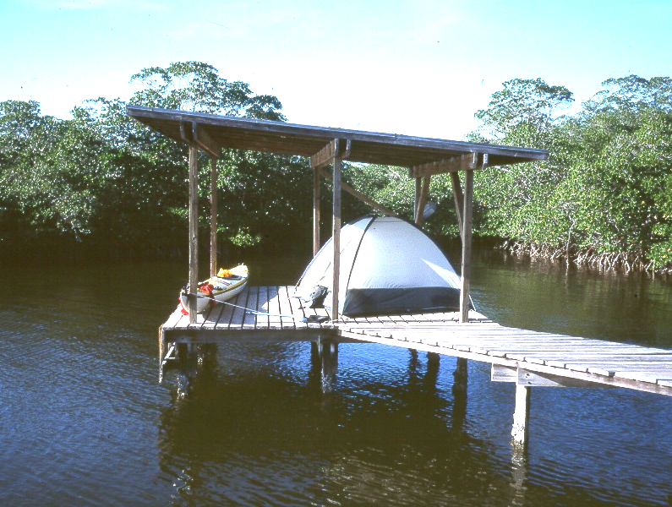
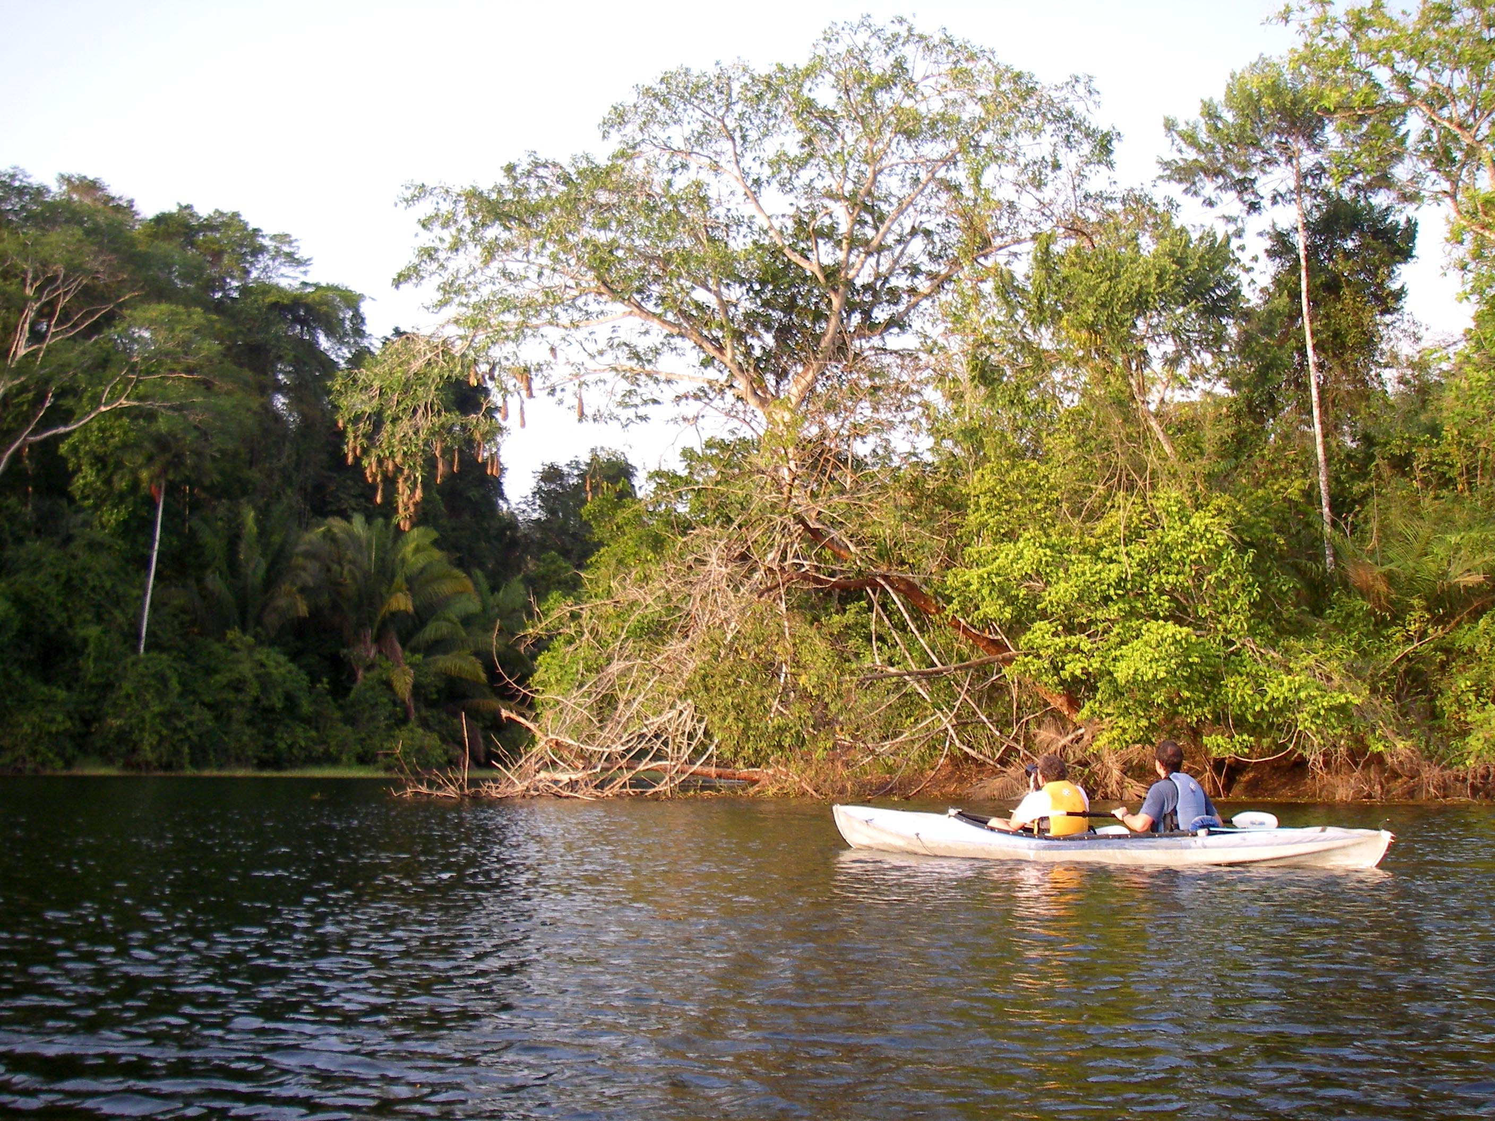
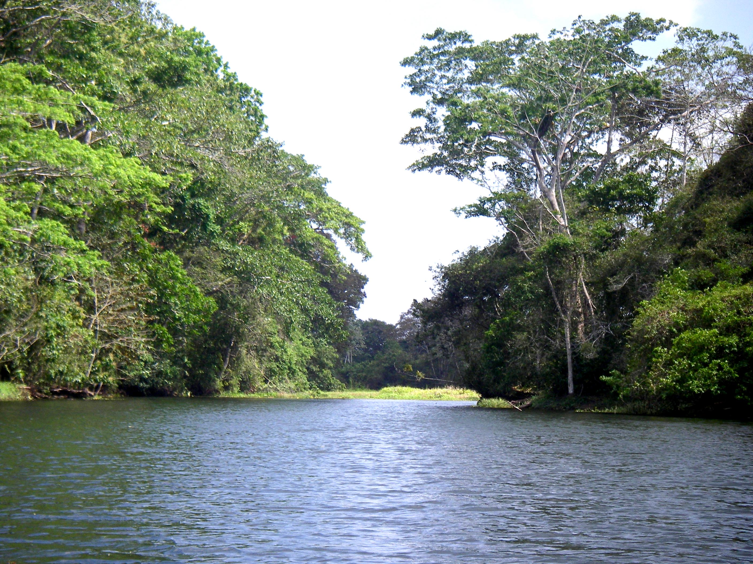
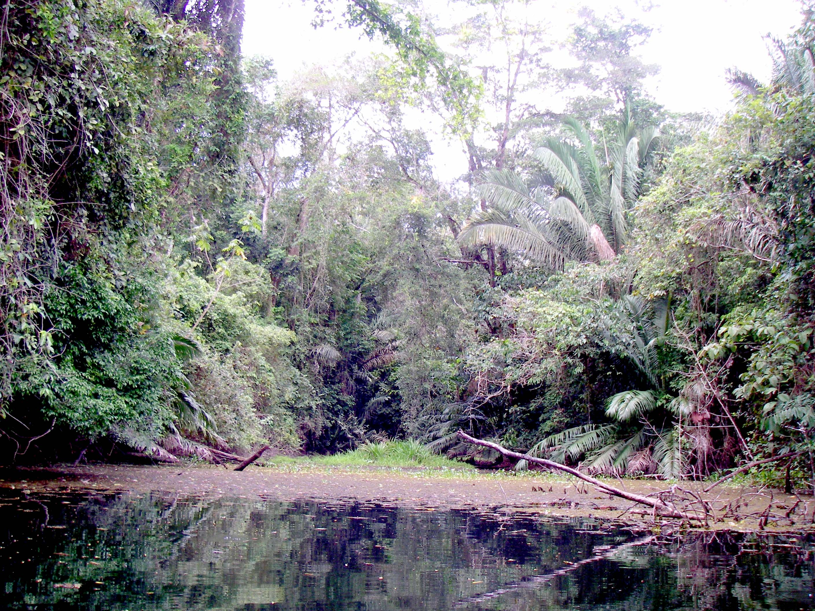
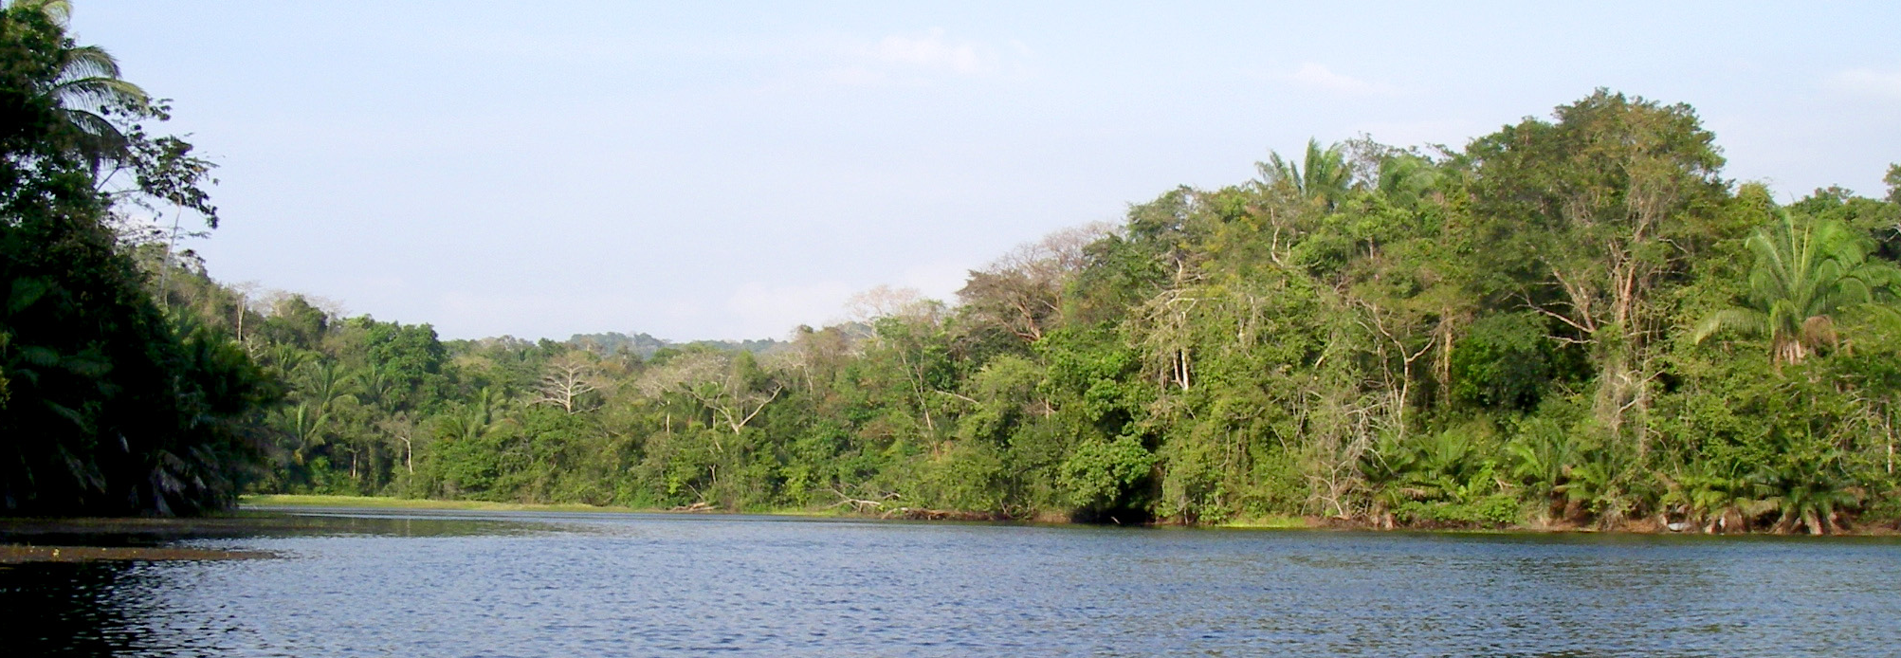
“Chickee” shelter for camping in the Everglades National Park, Florida (photo by Hank McComas).
Oropendola nests on one of the two islands.
View of the southern end of the lake.
Weeds clog the ends of the smaller arms of the lake during the dry season.
View of the northeastern end of the lake showing the location of the trail from the tower (arrow) and possible location for a boating dock
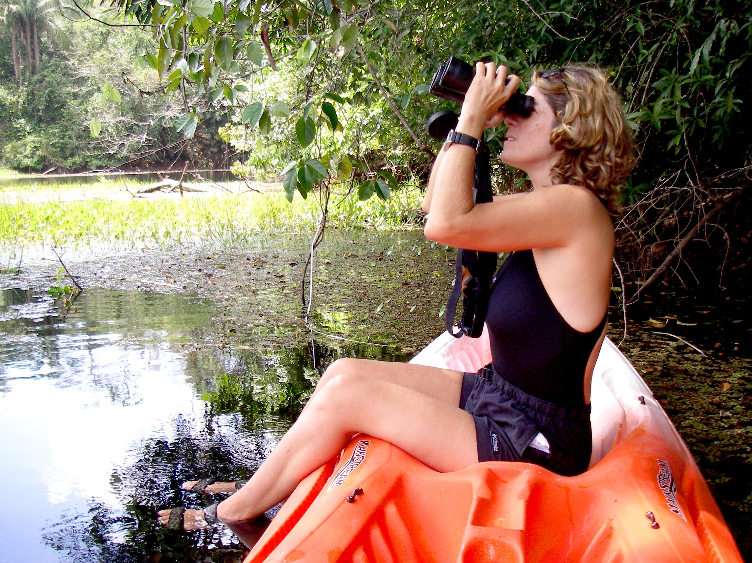
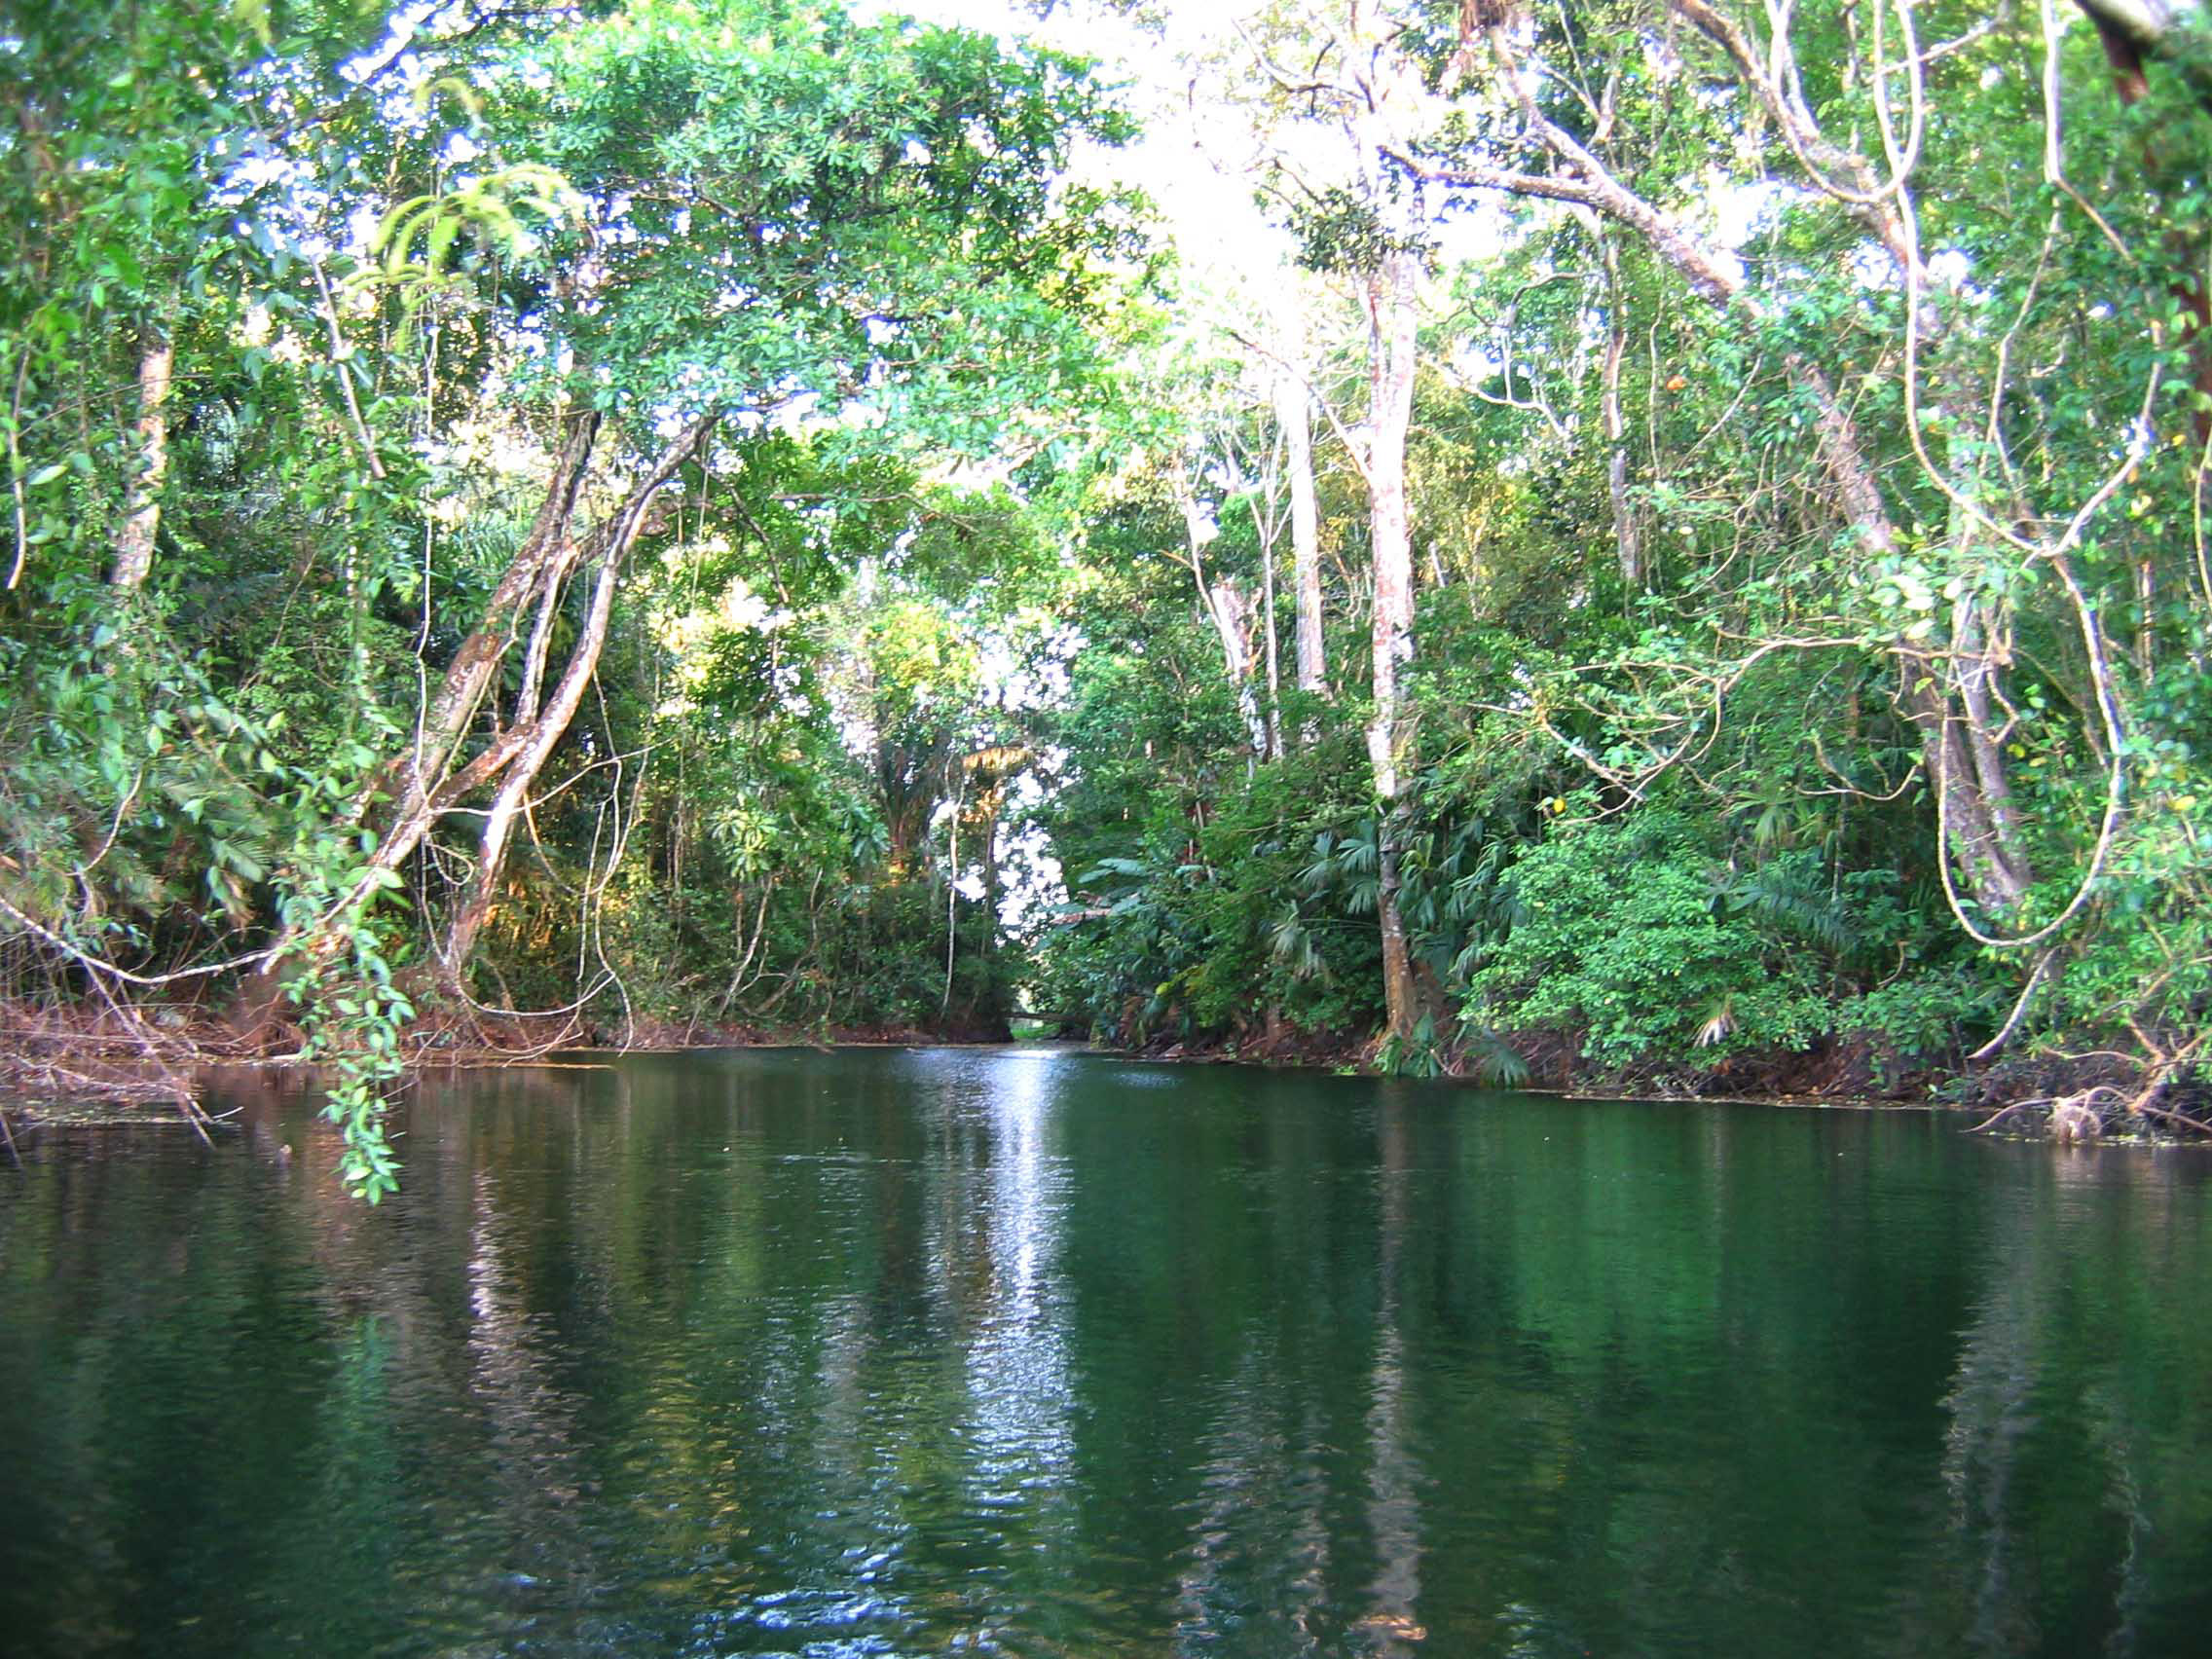
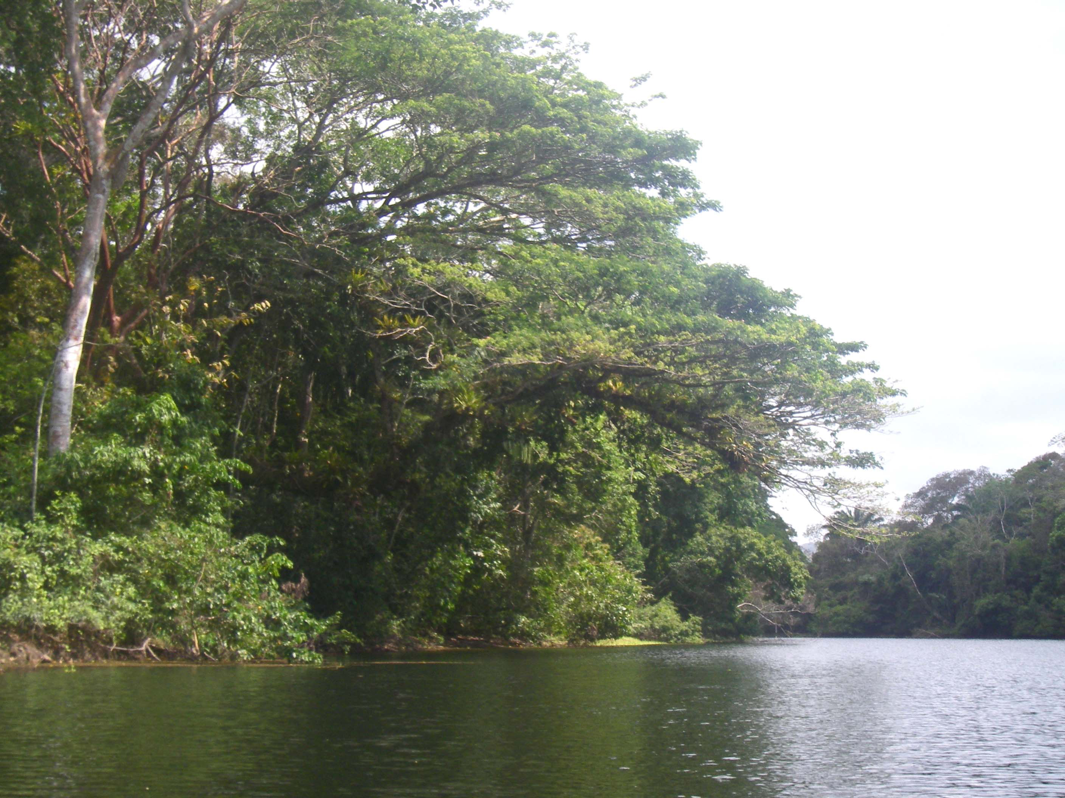
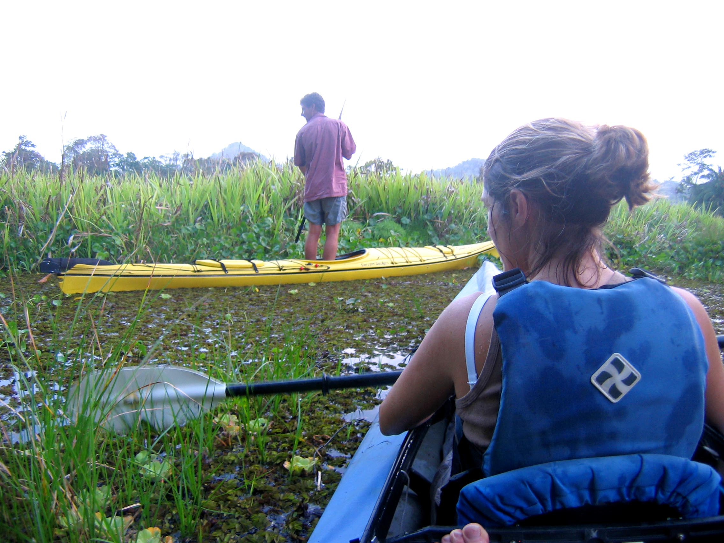
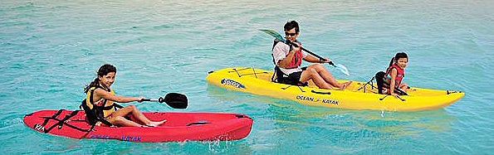
The southern end of the lake has a large mat of floating vegetation.
View south of the large tree with overhanging branches filled with epiphytes.
Sit-on-top kayaks are wetter than canoes but safer and easier to paddle.
The “cathedral” is a narrow channel on the southeast side of the lake flanked by tall trees.
Ocean Kayak is popular brand of sit-on-tops that has good floatation to keep paddlers relatively dry and can be stacked for convenient storage and transportation (Photo by Ocean Kayak).

LAGO CALAMITO POINTS OF INTEREST

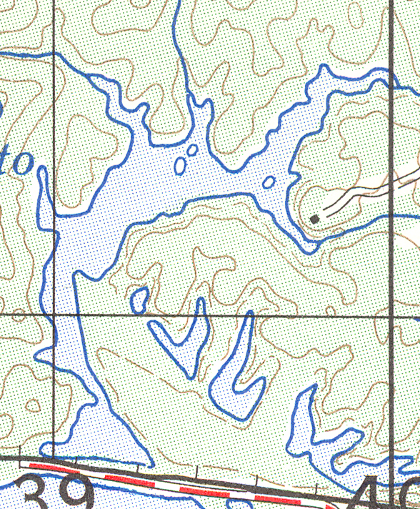
Tall Tree
Oropendola Nest Tree
Fallen Tree Floating
“Cathedral”
Floating Vegetation
Two Forested Islands
Large Tree with Epiphytes
Railroad Tracks
Lake Gatun
Low Grassy Island
Trail from Visitor Center

